Joshua, Nathan, Hasan

Step 1:
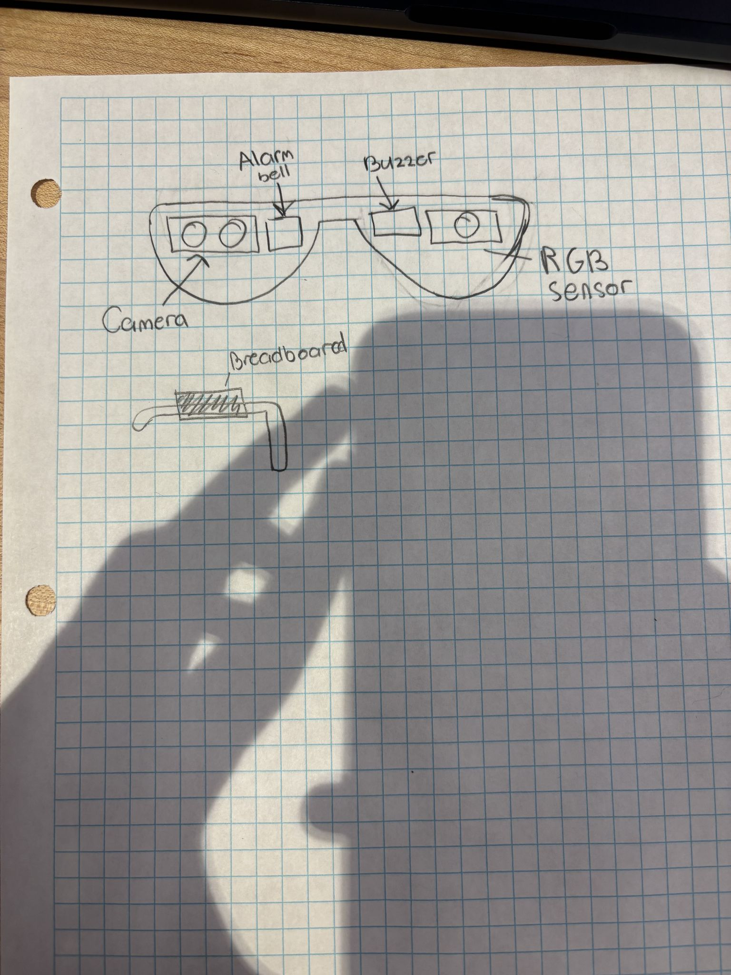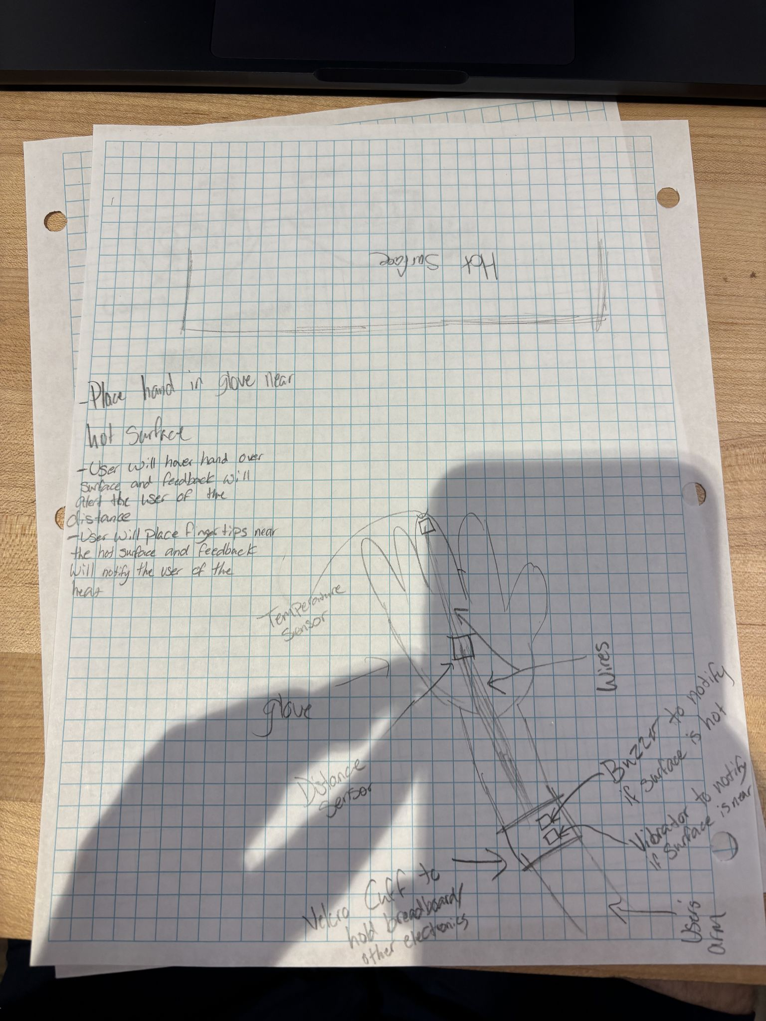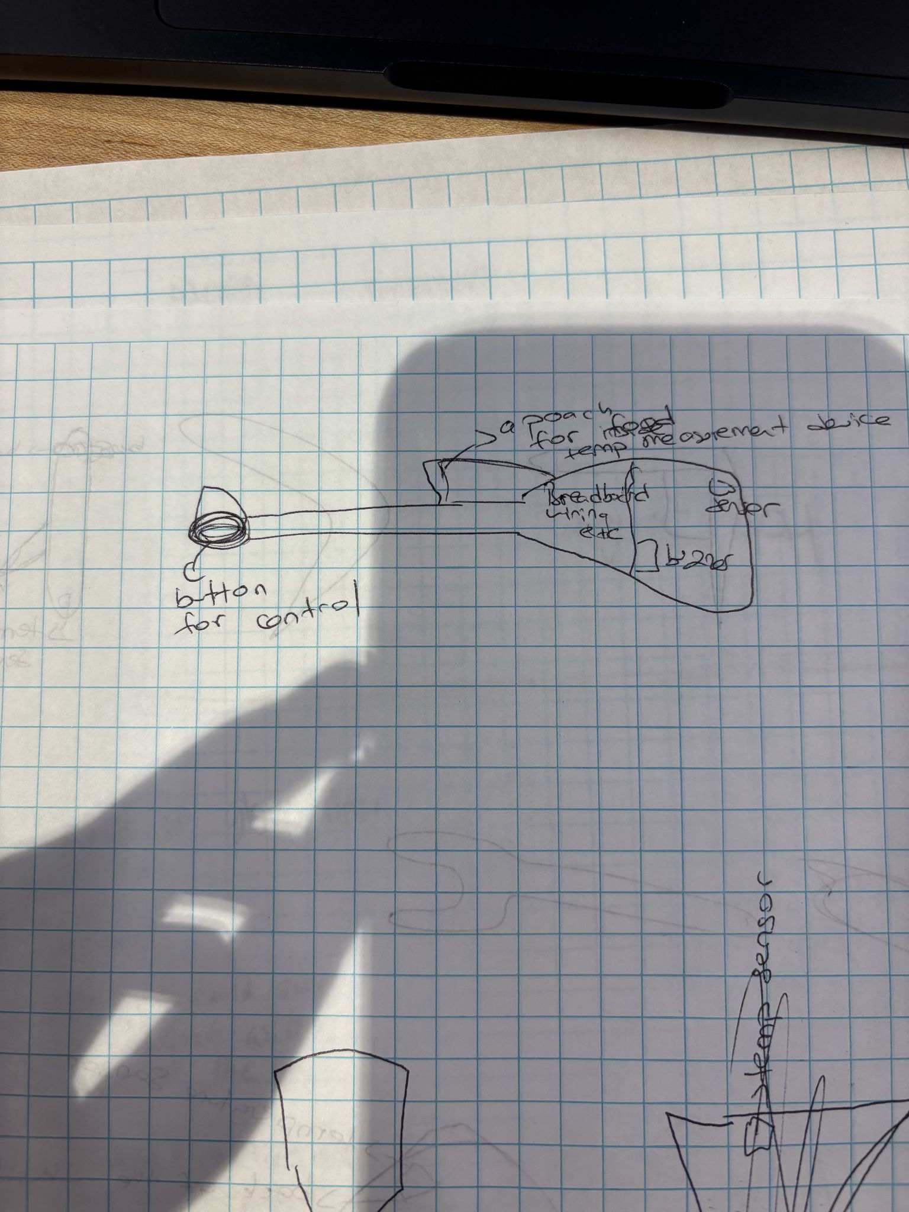

Step 2:

Criteria / Requirement | Weight | Idea 1 rating  (Kitchen Utensil) | Idea 2 rating  (Glove) | Idea 3 rating  (Glasses)
Functionality | 6 | 12 | 18 | 18
Feasibility | 5 | 5 | 10 | 15
Comfortability | 2 | 6 | 4 | 2
Cost | 2 | 6 | 6 | 6
Wire Management | 4 | 8 | 8 | 4
 | Total | 37 | 46 | 45

Step 3:
The description should include details of the inputs and outputs that you will include.
Inputs:
- Temperature Sensor
- Ultrasonic Range Sensor
Outputs:
- Vibrator (To alert user of the distance to the surface of an object)
- Buzzer (For sound to alert the user when the temperature is hot)
Please add a detailed list of the things (sensors, garments, objects) that you will need to develop your product.
- Temperature Sensor
- Ultrasonic Range Sensor
- Buzzer
- Vibrator
- Breadboard
- Thick Material Glove
- Wires
- Electrical tape (For wire management)
- Raspberry PI
- Velcro cuff
FINAL DRAWING
